**Social Emotional Learning & Behavioral**

**Supports and Interventions**

*School-Wide and Classroom Protocols and Strategies*

*This seminar is designed for individual educators and school or district-based teams interested in developing efficient protocols and strategies for addressing the needs of all students.*

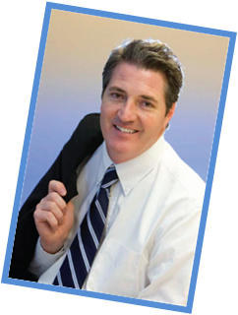

**-** **With National RTI Consultant/Trainer, Wayne Callender**

Wayne Callender is an author and national RTI Consultant who has worked at the State, district and building levels improving educational outcomes. Wayne currently trains and advises educators across the country in the implementation of systems for school improvement, both on-site and through nationwide seminars. In addition to being featured as keynote speaker at over a dozen state and national conferences, Wayne has authored numerous articles, chapters and training books on the implementation of a School-Wide Approach to RTI and improved instructional practices.

**PARTICIPANTS WILL LEAVE WITH:**

* Example Social, Emotional, and Behavioral Pathways
* A review list of existing social, emotional and behavioral universal screeners, including strengths, weaknesses, and costs
* Sample Universal Screener Timeline
* The top 10 classroom management strategies for all students
* Evidence based Tier 2 interventions (for both externalizing and internalizing behaviors)
* Evidence based Tier 3 interventions (for both externalizing and internalizing behaviors)
* A plan for managing Functional Behavioral Assessments (FBAs) when they are/are not necessary
* Much more.

**FOCUS AREAS INCLUDE:**

* A review of social emotional learning focus areas and instructional programs
* Social, emotional, and behavioral pathways linking evidence-based interventions to specific student needs
* A plan for screening, internalizing, and externalizing behaviors
* Tier 1 best practices - school-wide and classroom management strategies
* Tier 2 – Definition and interventions
* Tier 3 – Definition and interventions

**The DoubleTree**

**Minneapolis – University Area**

511 Huron Blvd.

Minneapolis, MN 55414

April 16, 2020

9:00am – 3:00pm

*Sign-in and Breakfast 8:30am-9:00am*

*Lunch 12:00pm-1:00pm (on your own)*

General Admission $199

Group discounts available for teams of 5 or more

**REGISTER NOW**

Partners for Learning, Inc.

[www.partnersforlearning.org](http://www.partnersforlearning.org/)

(208) 322-5007